

Mini Project Report - 07

Master of Computer Application
Semester – I

Sub: Front-End Frameworks and Technologies

Topic: Resume Website with CSS Styling

By
Name: YUVRAJ PAARTH
Reg no: PROV/ASAC/MCA/7/26/083

Faculty Name: VEERA RAGHAV K

Faculty Signature: _______________

Department of Computer Application
Alliance University
Chandapura - Anekal Main Road, Anekal
Bengaluru - 562 106
August 2026

INDEX

sl no | Topics | Pg no
1 | Introduction | 2
2 | Input | 3-10
3 | Output | 11-13
4 | Conclusion | 14

INTRODUCTION
The Portfolio Website is a personal showcase built to display professional skills, projects, and achievements to potential employers and collaborators. Developed using semantic HTML5, CSS3, and responsive design principles, the website provides a comprehensive overview of the developer's technical expertise and project portfolio. The site features a modern grid-based layout, smooth animations, and interactive hover effects that create an engaging user experience while maintaining clean, organized code structure.

INPUT

<html lang="en">
<head>
<title>Resume Website</title>
<link rel="stylesheet" href="style.css">
<meta name="viewport" content="width=device-width, initial-scale=1.0">
</head>
<body>
<!-- 1. HERO / HEADER -->
<header>
<img src="./Photo.jpeg" alt="Profile Photo">
<h1>Yuvraj</h1>
<p>Aspiring Frontend Developer | HTML, CSS, JS, SQL</p>
<nav>
<a href="#about">About</a>
<a href="#skills">Skills</a>
<a href="#projects">Projects</a>
<a href="#education">Education</a>
<a href="#contact">Contact</a>
</nav>
</header>
<br><br>
<!-- 2. ABOUT -->
<section id="about">
<h2>About Me</h2>
<p>I am an enthusiastic Frontend Developer who use java as integration with AI.</p>
</section>
<br><br>
<!-- 3. SKILLS -->
<section id="skills" class="skills">
<h2>Skills</h2>
<ul class="ski-style">
<li>
<img src="./html.png" alt="html">
<span>HTML</span>
</li>
<li>
<img src="./css.png" alt="css">
<span>CSS</span></li>
</li>
<li>
<img src="./js.png" alt="js">
<span>JavaScript</span>
</li>
<li>
<img src="./Python.png" alt="python">
<span>Python</span>
</li>
<li>
<img src="./java.png" alt="java">
<span>Java</span>
</li>
<li>
<img src="./mysql.png" alt="mysql">
<span>MySQL</span>
</li>
</ul>
</section>
<br><br>
<!-- 4.ACHIEVEMENTS -->
<section id="achievements" class="achievement-section">
<h2>Achievements</h2>
<div class="achievement-grid">
<div class="achievement-card">
<h3>Hackathon Finalist</h3>
<p>Top 50 team out of 500+ teams - SIH 2026</p>
</div>
<br><br>
<div class="achievement-card">
<h3>Data Science Internship</h3>
<p>Completed structred internships in MentorNess and CFSS</p>
</div>
<br>
<br>
</div>
</section>
<!-- 5. PROJECTS -->
<section id="projects">
<h2>Projects</h2>
<div class="project">
<div class="wid">
<h3>Chess</h3>
<img src="./Chess.png" alt="chess">
<p>HTML CSS</p>
<p class="description">Interactive chess board layout with responsive grid design. Demonstrates CSS positioning and board game UI patterns.</p>
<a href="#">GitHub</a> | <a href="projects/Chess.html">Link</a>
</div>
<div class="hei">
<h3>Birthday Card</h3>
<img src="./Birthday_Card.png" alt="card">
<p>HTML CSS</p>
<p class="description">Animated greeting card with CSS transitions and hover effects. Features creative typography and colorful design patterns.</p>
<a href="#">GitHub</a> | <a href="projects/Birthday Card.html">Link</a>
</div>
<div class="hei">
<h3>Krishna Special</h3>
<img src="./Krishna.png" alt="krishna">
<p>HTML CSS</p>
<p class="description">Themed visual design project showcasing CSS creativity. Uses layering and color blending to create artistic compositions.</p>
<a href="#">GitHub</a> | <a href="projects/Krishna Special.html">Link</a>
</div>
<div class="wid">
<h3>Semantic Dashboard</h3>
<img src="./Semantic_Dep_Website.png" alt="semantic website">
<p>HTML CSS</p>
<p class="description">Built with semantic HTML5 elements (header, nav, section, footer). Clean layout demonstrating proper document structure and accessibility.</p>
<a href="#">GitHub</a> | <a href="projects/Semantic Dashboard.html">Link</a>
</div>
</div>
</section>
<br><br>
<!-- 6. EDUCATION -->
<section id="education">
<h2>Education</h2>
<p>Masters — Alliance University — 2026-2028</p>
<br>
<p>Bachelors — Jain University — 2021-2024</p>
</section>
<br><br>
<!-- 7. CONTACT -->
<section id="contact">
<h2>Contact</h2>
<p>Email: yuvraj.works1@gmail.com</p>
<a href="https://www.linkedin.com/in/yuvraj-data-analyst/">LinkedIn</a> |
<a href="https://github.com/YuvrajPaarth">GitHub</a>
</section>
<!-- 8. DOWNLOAD -->
<section id="download" class="download-section">
<button type="button">
<img src="./download.png" alt="download">
<p>Download</p>
</button>
</section>
</body>
</html>

CSS:

*{
margin: 0;
padding: 0;
box-sizing: border-box;
}
header img {
width: 120px;
height: 120px;
margin-top: 30px;
border-radius: 50%;
object-fit: cover;
}
section {
max-width: 900px;
margin: 0;
padding: 60px 20px;
}
h1, h2, h3 {
margin-bottom: 15px;
}
h2 {
font-size: 28px;
text-align: center;
color: rgba(255, 90, 90, 0.817);
}
a {
color: #2a5bd7;
text-decoration: none;
}
a:hover {
text-decoration: underline;
}
body{
font-family: Arial, Helvetica, sans-serif;
font-size: 16px;
line-height: 1.6;
color: #222;
background: #fafafa;
font-style:initial;
display: flex;
flex-direction: column;
align-items: center;
text-align: center;
background-color: rgb(255, 214, 176);
}
nav a{
margin: 40px;
}
nav{
margin-top: 20px;
}
.ski-style{
display: flex;
flex-direction: row;
}
span{
font-weight: bold;
margin: 30px;
}
.wid img{
height: 150px;
width: 200px;
}
.hei img{
height: 200px;
width: 200px;
}
.wid, .hei {
transition: transform 0.25s ease, box-shadow 0.25s ease;
background: #fff;
border: 1px solid #e5e5e5;
border-radius: 8px;
padding: 15px;
}
.wid:hover, .hei:hover {
transform: translateY(-6px);
box-shadow: 0 10px 20px rgba(0,0,0,0.12);
}
.project{
display: grid;
grid-template-columns: repeat(2, 1fr);
gap: 25px;
}
.description{
font-size: 10px;
}
@media (max-width: 600px) {
.project { grid-template-columns: 1fr; }
}
ul img{
height: 20px;
width: 20px;
}
.ski-style{
list-style: none;
padding: 0px;
margin: 0px;
flex-wrap: wrap;
display: flex;
flex-direction: row;
align-items: center;
justify-content: center;
}
.skills{
align-items: center;
text-align: center;
}
.download-section {
height: 30px;
width: 50px;
border-radius: 80%;
text-align: center;
}
.download-section {
display: flex;
justify-content: center;
align-items: center;
padding: 40px 20px;
}
.download-section img {
height: 30px;
width: 30px;
object-fit: cover;
border-radius: 80%;
}

OUTPUT

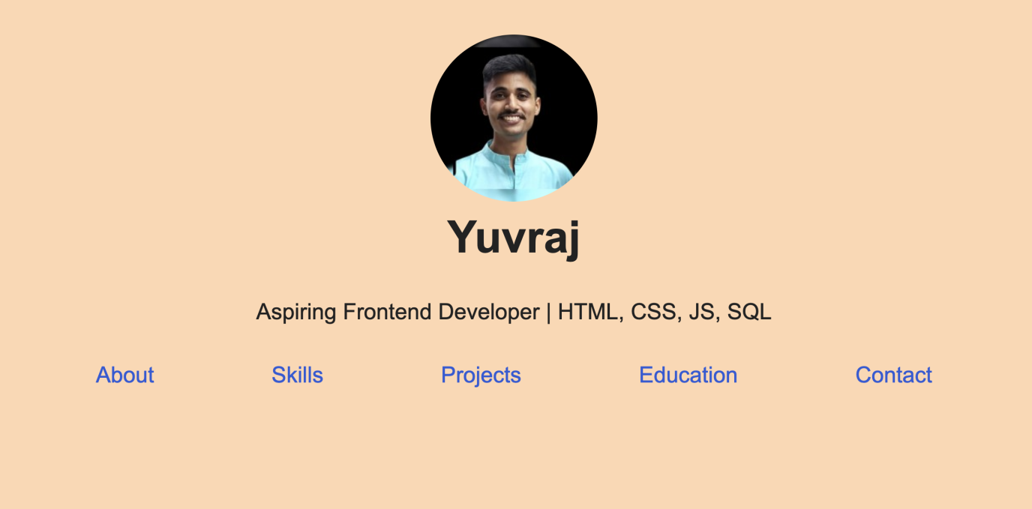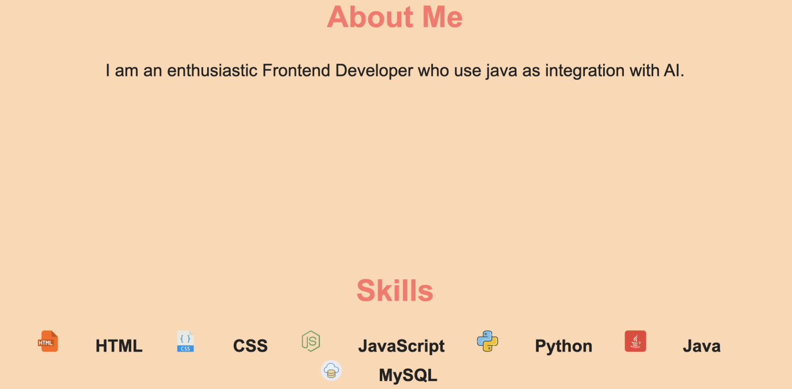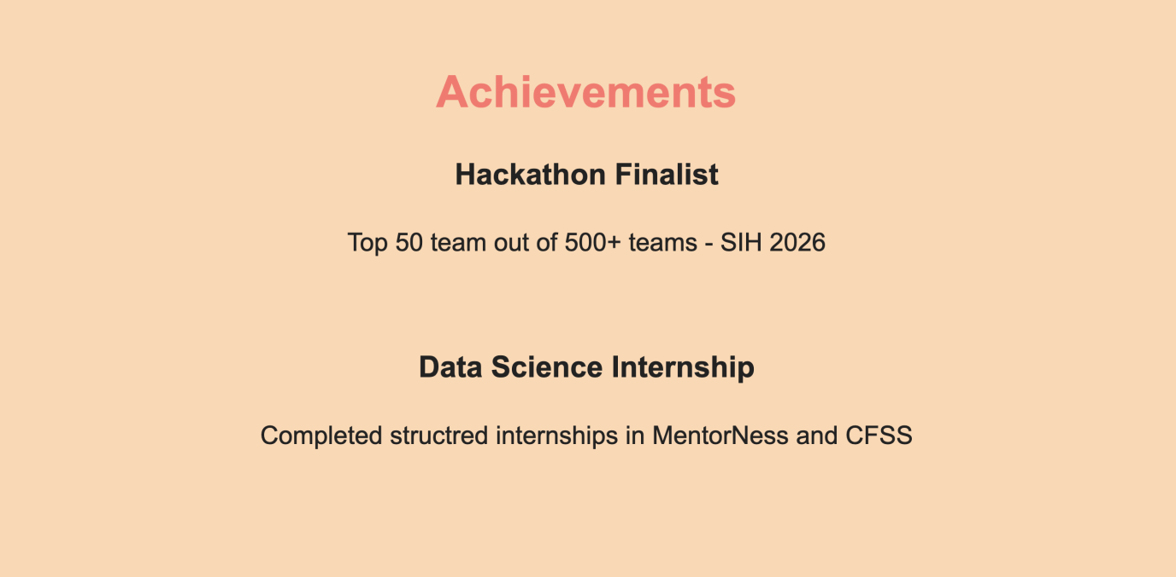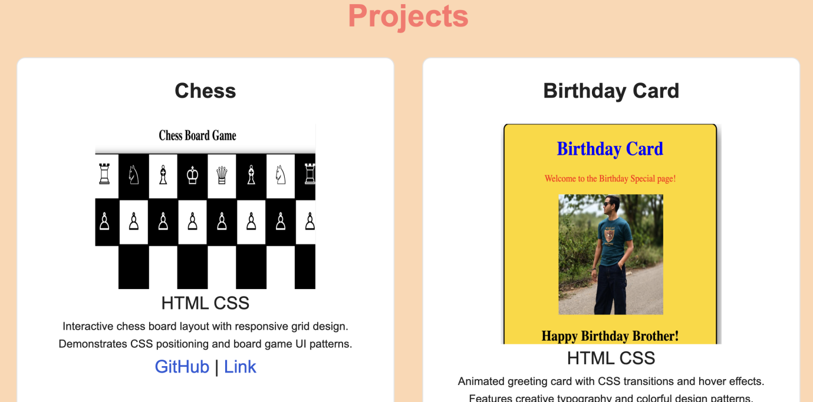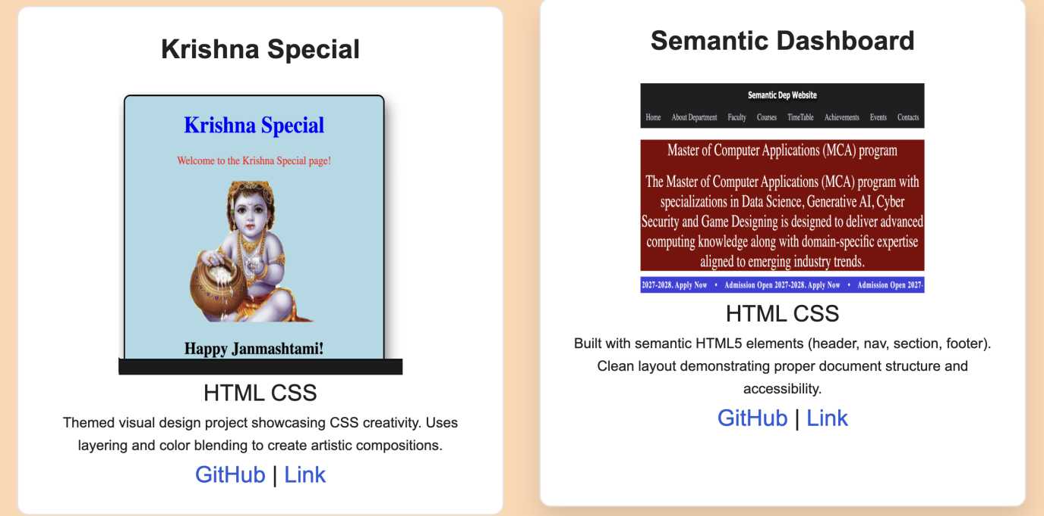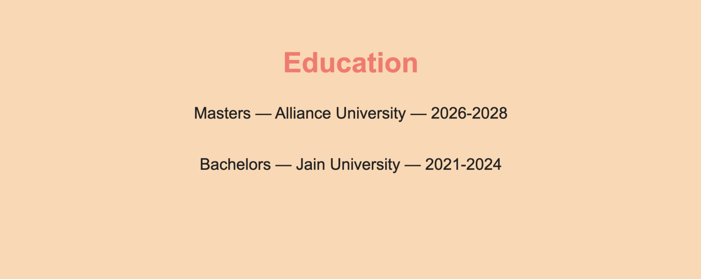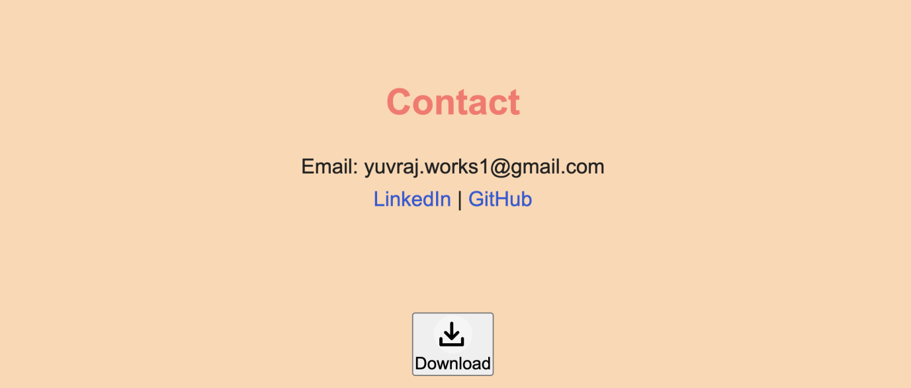

CONCLUSION

The Portfolio Website project successfully demonstrates the integration of HTML, CSS, and responsive web design to create a professional, visually appealing personal brand. The website effectively showcases key information including technical skills, notable projects, educational background, and contact details through a well-organized, multi-section layout. The implementation of CSS Grid for responsive project cards, smooth hover transitions, and a color-coordinated design scheme provides an engaging user experience across all device sizes.
The project meets all requirements by presenting a complete portfolio that highlights the developer's expertise in frontend technologies including HTML, CSS, JavaScript, Python, Java, and MySQL. The inclusion of achievement highlights, detailed project descriptions, and easy navigation demonstrates effective information architecture. The responsive design ensures accessibility on mobile, tablet, and desktop platforms, while the professional styling and clean typography create a strong first impression for recruiters and clients.

